Project Development Phase
Model Performance Test

Date | 10 February 2026
Team ID | LTVIP2026TMIDS75194
Project Name | Deep Learning Fundus Image Analysis for Early Detection of Diabetic Retinopathy
Maximum Marks

Model Performance Testing:
Project team shall fill the following information in model performance testing template.
S.No. | Parameter | Values | Screenshot
 | Model Summary | Deep learning convolutional neural network model developed for retinal fundus image classification. The model consists of convolution layers, pooling layers, activation functions, fully connected layers, and softmax output for classification of diabetic retinopathy stages. | 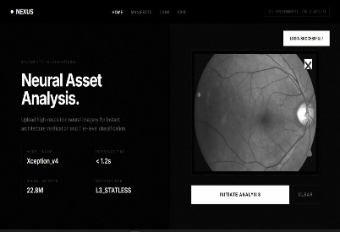
 | Accuracy | Training Accuracy - 96%  Validation Accuracy - 94% | 
3. | Fine Tunning Result( if Done) | Validation Accuracy - 96%

